Hospital Directory Analysis

Project Report
Prepared By
Name: Rajasree
Course: Data Analysis with AI
Tool Used: Microsoft Power BI and Excel
1. Introduction

Healthcare infrastructure plays a crucial role in providing quality medical services. This project analyses a hospital directory dataset using Microsoft Power BI to understand the distribution of hospitals across different states, hospital categories, care types, and systems of medicine.
The objective is to transform raw hospital data into meaningful visual insights that support decision-making.

2. Objectives

The objectives of this project are:
- Analyse the distribution of hospitals across India.
- Identify the states with the highest number of hospitals.
- Compare public and private hospitals.
- Analyse different hospital care types.
- Build an interactive dashboard using Power BI.
- Enable users to filter data using slicer

3. Dataset Description

Dataset Name: Hospital Directory Dataset

The dataset used for this project is the Hospital Directory Dataset, which contains information about hospitals across different states and union territories of India. It provides comprehensive details about healthcare institutions, including their location, category, care type, medical systems, and available facilities.

The dataset consists of more than 30,000 records and includes information such as:
- Hospital Name
- State
- District
- Hospital Category
- Hospital Care Type
- System of Medicine
- Facilities
- Specialties
- Accreditation
- Emergency Services

The dataset also originally included additional information such as contact numbers, email addresses, website details, geographic coordinates, and registration details. However, these fields were not required for this analysis and were removed during the data cleaning process to improve the quality and efficiency of the dashboard.

4. Data Cleaning

Before creating the dashboard, the dataset underwent a comprehensive data cleaning and preprocessing process to improve its quality, consistency, and suitability for analysis. The original dataset contained over 30,000 hospital records along with several unnecessary columns such as contact details, email addresses, website links, geographic coordinates, registration information, and other administrative fields that were not relevant to the project objectives. These columns were removed to simplify the dataset and improve dashboard performance.

The following preprocessing steps were performed:

- Removed duplicate records to ensure data accuracy.
- Eliminated unnecessary columns that were not required for analysis.
- Identified and handled missing values wherever possible by replacing them with appropriate values or retaining them only when necessary.
- Trimmed unwanted spaces and cleaned text fields to maintain consistency.
- Standardized text values by correcting inconsistent formatting and naming conventions.
- Corrected data types to ensure that text, numeric, and categorical columns were properly recognized by Power BI.
- Removed irrelevant fields to optimize the dataset for dashboard development and improve report performance.

These preprocessing steps resulted in a clean, well-structured, and reliable dataset, enabling accurate calculations, effective visualizations, and meaningful insights through the interactive Power BI dashboard.

5. Tools & Technologies Used
Tool | Purpose
Microsoft Excel | Initial data cleaning and preprocessing
Power Query Editor | Data transformation and type correction
Microsoft Power BI Desktop | Dashboard creation and visualization
DAX | Creating calculated measures and KPIs

6. Data Modelling & DAX Measures
- The following DAX measures were created to summarize the dataset:
- Total Hospitals
- Total States
- Hospital Categories
- Total Districts

These measures were used to create KPI cards and support interactive dashboard analysis.

7. KPIs Created

The dashboard includes the following Key Performance Indicators:
- Total Hospitals
- Total States
- Hospital Categories
- Total Districts

8. Dashboard Visualizations

8.1 Excel Data Preparation

Microsoft Excel was used to remove unnecessary columns, clean text values, identify missing values, remove duplicates, and prepare the dataset before importing it into Power BI.

8.2 Power BI Dashboard

An interactive dashboard was developed using Microsoft Power BI to visualize and analyse the Hospital Directory Dataset. The dashboard was designed to provide a clear and user-friendly overview of hospital information across different regions of India.

The dashboard includes:

- KPI Cards showing Total Hospitals, Total States, Hospital Categories, and Total Districts.
- A bar chart displaying the Top 10 States by Number of Hospitals.
- A donut chart showing the distribution of hospitals by Hospital Category.
- A column chart representing hospitals by Hospital Care Type.
- A bar chart displaying the Top Districts by Number of Hospitals.
- Interactive slicers for State, Hospital Category, Hospital Care Type, and System of Medicine.

The dashboard allows users to filter the data dynamically and gain meaningful insights into the distribution and characteristics of hospitals across India.

Figure 1: Hospital Directory Analysis Dashboard
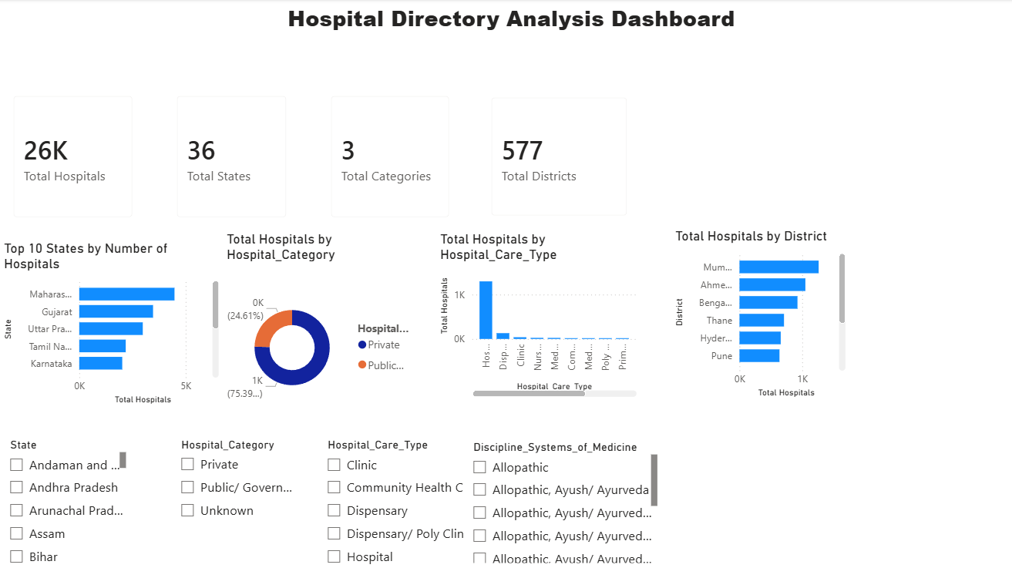

The final dashboard presents key insights from the Hospital Directory Dataset through interactive KPI cards, charts, and slicers. During the development process, challenges such as unnecessary columns, missing and inconsistent values, incorrect data types, and incomplete information in certain fields (such as doctor count and total beds) were addressed through data cleaning and preprocessing. Despite these limitations, the dashboard provides a clear and interactive visualization of hospital distribution across states, districts, hospital categories, and care types.

9. Insights

Based on the dashboard analysis, the following observations were made:
- Maharashtra has the highest number of hospitals among all the states in the dataset.
- The dataset includes hospitals from 35 states and 577 districts across India.
- Hospitals are classified into three major categories, with private hospitals forming a significant portion of the dataset.
- Different healthcare facilities such as hospitals, clinics, dispensaries, and community health centres are represented in the data.
- The interactive dashboard enables users to filter and compare hospital information across different locations and categories.

10. Conclusion

This project demonstrates how Microsoft Power BI can be used to transform raw healthcare data into an interactive and meaningful dashboard. Through data cleaning, transformation, and visualization, valuable insights into the distribution of hospitals across India were obtained. The dashboard provides a clear overview of healthcare infrastructure and enables users to explore hospital information interactively using filters and visualizations.
During the project, several challenges were encountered, including the presence of unnecessary columns, missing and inconsistent values, and incomplete data in fields such as the number of doctors and total number of beds, which limited their use in KPI analysis. Additionally, assigning appropriate data types and designing a well-structured, interactive dashboard required careful refinement. Overcoming these challenges highlighted the importance of proper data preprocessing and thoughtful dashboard design in producing accurate and meaningful business insights.

11. Future Enhancements

- Include real-time healthcare data.
- Add map visualizations.
- Improve analysis using complete doctor and bed information.
- Publish the dashboard to Power BI Service.
- Develop predictive healthcare analytics.

12. References
- Hospital Directory Dataset

Thank You

